**Information System Management Lab**

**BCOM 307**

**Assignment #26**

***Submitted by:***

**Name:** YASH JAIN

**Enrollment No:** 03914788818

**Semester:** B.Com(H) 5th Semester

**Class:** B.COM(H)

**Section:** B.Com 5A

**Date of Submission:** 12/11/2021

***Submitted to:***

**Praveen Kumar Singh**

**Assistant Professor, MAIMS**



**Department of Commerce**

**Maharaja Agrasen Institute of Management Studies**

**Affiliated to Guru Gobind Singh Indraprastha University, Delhi**

**Sector -22, Rohini, Delhi -110086, India; www.maims.ac.in**

Maharaja Agrasen Institute of Management Studies

Affiliated to GGS IP University; Recognized u/s 2(f) of UGC Recognized by Bar Council of India; ISO 9001: 2015

Certified Institution Sector 22, Rohini, Delhi -110086, India; [www.maims.ac.in](http://www.maims.ac.in/)

Department of Commerce

Academic Year: 2020-21

Semester: Vth

# Assignment No. 26

# Unit No:

**Course/Subject Code:** BCOM 307 **Subject Title: Information System Management Lab**

# Issue Date Last Date of Submission:

**Instructions for Students:**

# All Questions are Compulsory.

1. The student should attach proper cover page for each assignment clearly mentioning the Assignment No.
2. Each assignment should be prepared by the student individually with proper explaination and screenshots.
3. A4 size ruled sheets should be used for the assignment.
4. Assignment pages should be serially numbered at the bottom of page.

***During online education mode, upload scanned copy of the complete assignment including cover page latest by due date.***

|  |  |  |
| --- | --- | --- |
| **Question No.** | **Question** | **CO No.** |
| 1 | Create a table with the given attributes :  **Table Name : Clients**   |  |  |  |  |  | | --- | --- | --- | --- | --- | | **Column_Name** | **Data Type** | **Size** | **Default** | **Attributes** | | CLIENT_NO | VARCHAR | 6 |  | Primary key/  first letter must  start with C | | NAME | VARCHAR | 20 |  | NOT NULL | | CITY | VARCHAR | 15 |  |  | | PINCODE | INTEGER |  |  |  | | STATE | VARCHAR | 15 |  |  | | BALDUE | INTEGER |  |  |  | | **CO1, CO2** |
| 2 | Insert the following into the Clients table :   |  |  |  |  |  |  | | --- | --- | --- | --- | --- | --- | | **CLIENT_NO** | **NAME** | **CITY** | **PINCODE** | **STATE** | **BALDUE** | | C0001 | Ivan Bayross | Mumbai | 400054 | Maharashtra | 15000 | | C0002 | MamtaMuzumdar | Madras | 780001 | Tamil Nadu | 0 | | C0003 | ChhayaBankar | Mumbai | 400057 | Maharashtra | 5000 | | C0004 | Ashwini Joshi | Banglore | 560001 | Karnataka | 0 | | **CO1,**  **CO2** |
| 3 | Create the following table with the given attributes:  **Table Name: Products**   |  |  |  |  |  | | --- | --- | --- | --- | --- | | **Column_Name** | **Data Type** | **Size** | **Default** | **Attributes** | | PRODUCT_NO | VARCHAR | 6 |  | Primary key/  first letter must  start with P | | DESCRIPTION | VARCHAR | 15 |  | NOT NULL | | QTY_ON_HAND | INTEGER |  |  | NOT NULL | | REORDER_LEVEL | INTEGER |  |  | NOT NULL | | SELL PRICE | INTEGER |  |  | NOT NULL,  CANNOT BE 0 | | COST PRICE | INTEGER |  |  | NOT NULL,  CANNOT BE 0 | |
| 4 | Insert the following values in the PRODUCTS table:   |  |  |  |  |  |  | | --- | --- | --- | --- | --- | --- | | **PRODUCT_NO** | **DESCRIPTION** | **QTY_ON**  **HAND** | **REORDER_LEVEL** | **SELL PRICE** | **COST PRICE** | | P00001 | T-shirts | 200 | 50 | 350 | 250 | | P0345 | Shirts | 150 | 50 | 500 | 350 | | P06734 | Cotton Jeans | 100 | 20 | 600 | 450 | | P07865 | Jeans | 100 | 20 | 750 | 500 | |
| 5 | Create the following table with the given attributes:  **Table Name: SALESMAN**   |  |  |  |  |  | | --- | --- | --- | --- | --- | | **Column_Name** | **Data Type** | **Size** | **Default** | **Attributes** | | SALESMAN_NO | VARCHAR | 6 |  | Primary key/  first letter must  start with S | | SALESMAN_NAME | VARCHAR | 20 |  | NOT NULL | | CITY | VARCHAR | 20 |  |  | | PINCODE | INTEGER |  |  |  | | STATE | VARCHAR | 20 |  |  | | SALES_AMOUNT | INTEGER |  |  | NOT NULL,  CANNOT BE 0 | | **CO1, CO2** |
| 6 | Insert the following values in the SALESMAN table:   |  |  |  |  |  |  | | --- | --- | --- | --- | --- | --- | | **SALESMAN_NO** | **SALESMAN_NAME** | **CITY** | **PINCODE** | **STATE** | **SALES_AMT** | | S00001 | AMAN | MUMBAI | 400002 | Maharashtra | 3000 | | S00002 | Omkar | MUMBAI | 400001 | Maharashtra | 3000 | | S00003 | Raj | MUMBAI | 400032 | Maharashtra | 3000 | | S00004 | Ashish | MUMBAI | 400044 | Maharashtra | 3500 | |
| 7 | Create the following table with the given attributes:  **Table Name: SALES_ORDER**   |  |  |  |  |  | | --- | --- | --- | --- | --- | | **Column_Name** | **Data Type** | **Size** | **Default** | **Attributes** | | ORDER_NO | VARCHAR | 6 |  | Primary key/  first letter must  start with O | | CLIENT_NO | VARCHAR | 6 |  | REFER  CLIENT_MASTER | | Order_date | DATE |  |  | NOT NULL | | Salesman_NO | VARCHAR | 6 |  | REFER  SALESMAN_MASTER | | ORDER_STATUS | VARCHAR | 10 |  | IN_PROCESS,  CANCELLED,  FULFILLED, BACK_  ORDER | |
| 8 | Insert the following values in the SALES_ORDER table:   |  |  |  |  |  | | --- | --- | --- | --- | --- | | **ORDER_NO** | **CLIENT_NO** | **Order Date** | **Salesman No** | **Order_status** | | O19001 | C00001 | 12-JUNE-2004 | S00001 | IN_PROCESS | | O19002 | C00002 | 25-JUNE-2004 | S00002 | CANCELLED | | O46865 | C00003 | 18-FEB-2004 | S00003 | FULFILLED | | O19003 | C00001 | 03-APR-2004 | S00001 | FULFILLED | | **CO1, CO2** |
| 9 | Create the following table with the given attributes:  **Table Name: SALES_ORDER_DETAILS**   |  |  |  |  |  | | --- | --- | --- | --- | --- | | **Column_ Name** | **Data Type** | **Size** | **Default** | **Attributes** | | ORDER_ NO | VARCHAR | 6 |  | REFER  SALES_ORDER | | PRODUCT_NO | VARCHAR | 6 |  | REFER  PRODUCT_MASTER | | QTY_ORDERED | INTEGER |  |  |  | |
| 10 | Insert the following values in the SALES_ORDER_DETAILS table:   |  |  |  | | --- | --- | --- | | **ORDER_NO** | **PRODUCT_NO** | **QTY_ORDERED** | | O19001 | P00001 | 4 | | O19002 | P00001 | 10 | | O19003 | P0345 | 4 | | O46865 | P07865 | 1 | |

**ASSIGNMENT 26 - BASIC COMMANDS PRACTICE**

**Task 1 : Create a table with the given attributes :**

Table Name : **Clients**

|  |  |  |  |  |
| --- | --- | --- | --- | --- |
| **Column_Name** | **Data Type** | **Size** | **Default** | **Attributes** |
| CLIENT_NO | VARCHAR | 6 |  | Primary key/  first letter must  start with C |
| NAME | VARCHAR | 20 |  | NOT NULL |
| CITY | VARCHAR | 15 |  |  |
| PINCODE | INTEGER |  |  |  |
| STATE | VARCHAR | 15 |  |  |
| BALDUE | INTEGER |  |  |  |

This task can be completed using the **CREATE TABLE** command. Along with the **Primary Key, Not Null** and **Check** constraints.

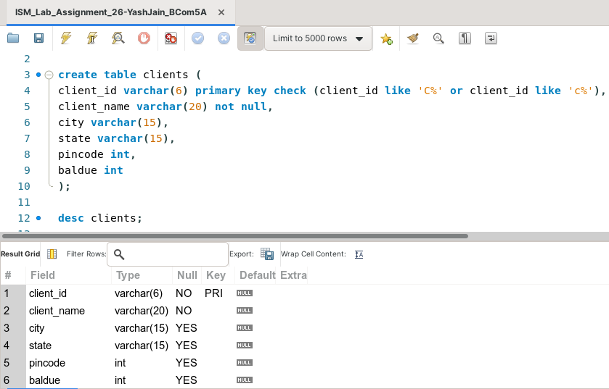

**Task 2: Insert the following values into the Clients table:**

|  |  |  |  |  |  |
| --- | --- | --- | --- | --- | --- |
| **CLIENT_NO** | **NAME** | **CITY** | **PINCODE** | **STATE** | **BALDUE** |
| C0001 | Ivan Bayross | Mumbai | 400054 | Maharashtra | 15000 |
| C0002 | Mamta Muzumdar | Madras | 780001 | Tamil Nadu | 0 |
| C0003 | Chhaya Bankar | Mumbai | 400057 | Maharashtra | 5000 |
| C0004 | Ashwini Joshi | Banglore | 560001 | Karnataka | 0 |

This task can be completed using the **INSERT INTO** command.

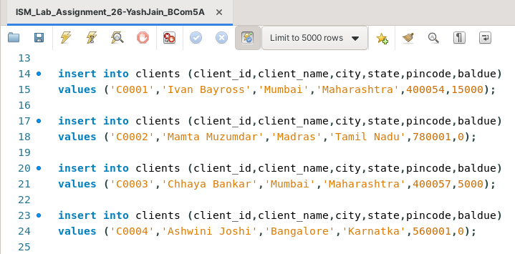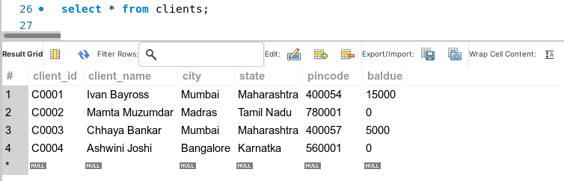

**Task 3: Create the following table with the given attributes:**

Table Name: **Products**

|  |  |  |  |  |
| --- | --- | --- | --- | --- |
| **Column_Name** | **Data Type** | **Size** | **Default** | **Attributes** |
| PRODUCT_NO | VARCHAR | 6 |  | Primary key/ first letter must  start with P |
| DESCRIPTION | VARCHAR | 15 |  | NOT NULL |
| QTY_ON_HAND | INTEGER |  |  | NOT NULL |
| REORDER_LEVEL | INTEGER |  |  | NOT NULL |
| SELL PRICE | INTEGER |  |  | NOT NULL, CANNOT BE 0 |
| COST PRICE | INTEGER |  |  | NOT NULL, CANNOT BE 0 |

This task can be completed using the **CREATE TABLE** command, along with the **Primary Key, Not Null** and **Check** constraints.

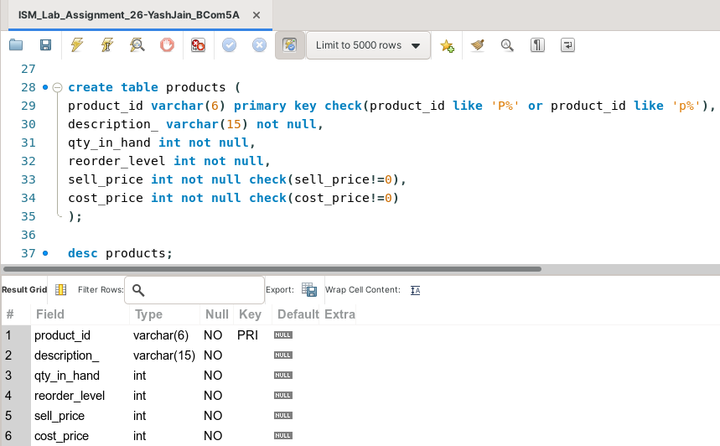

**Task 4: Insert the following values into the Clients table:**

|  |  |  |  |  |  |
| --- | --- | --- | --- | --- | --- |
| **PRODUCT_NO** | **DESCRIPTION** | **QTY_ON**  **HAND** | **REORDER_LEVEL** | **SELL PRICE** | **COST PRICE** |
| P0001 | T-shirts | 200 | 50 | 350 | 250 |
| P0345 | Shirts | 150 | 50 | 500 | 350 |
| P06734 | Cotton Jeans | 100 | 20 | 600 | 450 |
| P07865 | Jeans | 100 | 20 | 750 | 500 |

This task can be completed using the **INSERT INTO** Command.

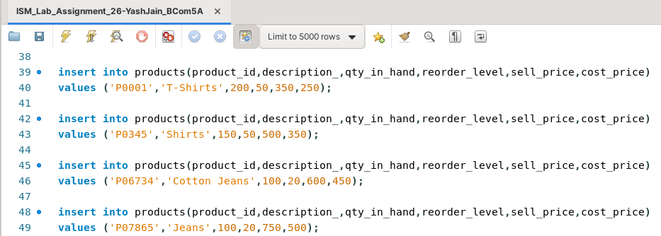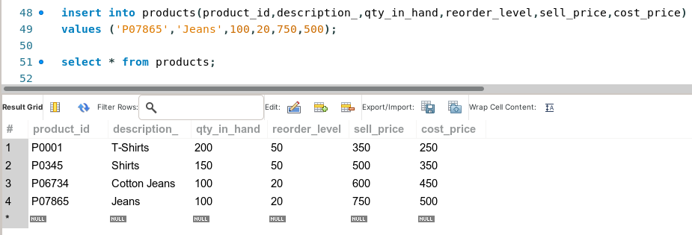

**Task 5: Create the following table with the given attributes:**

Table Name: **SALESMAN**

|  |  |  |  |  |
| --- | --- | --- | --- | --- |
| **Column_Name** | **Data Type** | **Size** | **Default** | **Attributes** |
| SALESMAN_NO | VARCHAR | 6 |  | Primary key/  first letter must  start with S |
| SALESMAN_NAME | VARCHAR | 20 |  | NOT NULL |
| CITY | VARCHAR | 20 |  |  |
| PINCODE | INTEGER |  |  |  |
| STATE | VARCHAR | 20 |  |  |
| SALES_AMOUNT | INTEGER |  |  | NOT NULL,  CANNOT BE 0 |

This task can be completed using the **CREATE TABLE** command, along with the **Primary Key, Not Null** and **Check** constraints.

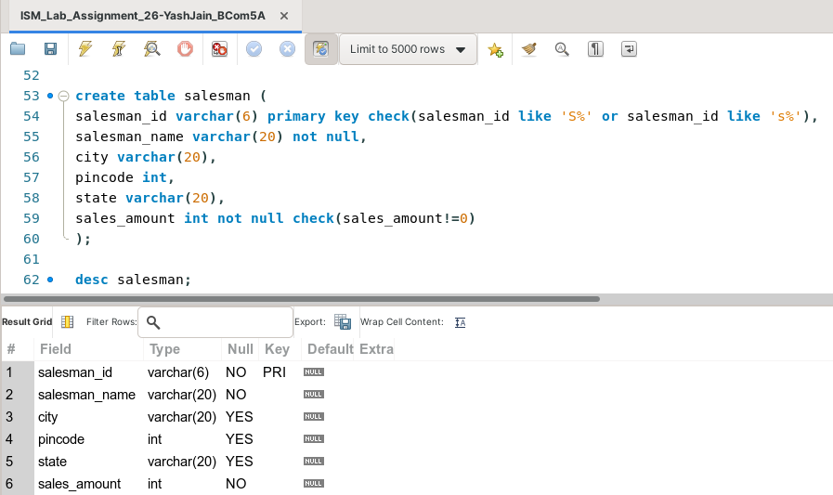

**Task 6: Insert the following values in the SALESMAN table:**

|  |  |  |  |  |  |
| --- | --- | --- | --- | --- | --- |
| **SALESMAN_NO** | **SALESMAN_NAME** | **CITY** | **PINCODE** | **STATE** | **SALES_AMT** |
| S00001 | AMAN | MUMBAI | 400002 | Maharashtra | 3000 |
| S00002 | Omkar | MUMBAI | 400001 | Maharashtra | 3000 |
| S00003 | Raj | MUMBAI | 400032 | Maharashtra | 3000 |
| S00004 | Ashish | MUMBAI | 400044 | Maharashtra | 3500 |

This task can be completed using the **INSERT INTO** Command.

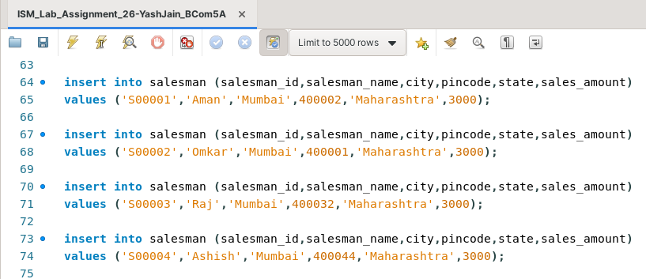

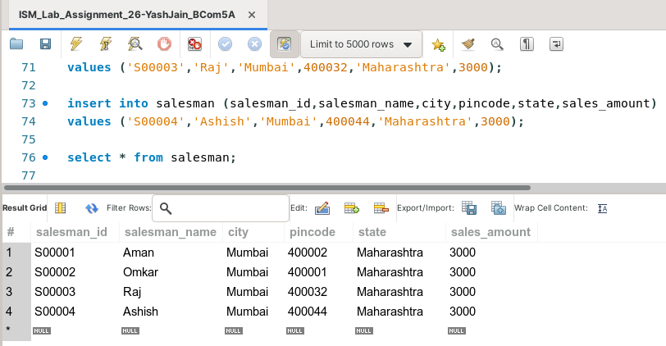

**Task 7: Create the following table with the given attributes:**

Table Name: **SALES_ORDER**

|  |  |  |  |  |
| --- | --- | --- | --- | --- |
| **Column_Name** | **Data Type** | **Size** | **Default** | **Attributes** |
| ORDER_NO | VARCHAR | 6 |  | Primary key/  first letter must  start with O |
| CLIENT_NO | VARCHAR | 6 |  | REFER  CLIENT_MASTER |
| Order_date | DATE |  |  | NOT NULL |
| Salesman_NO | VARCHAR | 6 |  | REFER  SALESMAN_MASTER |
| ORDER_STATUS | VARCHAR | 10 |  | IN_PROCESS,  CANCELLED,  FULFILLED, BACK_  ORDER |

This task can be completed using the **CREATE TABLE** command, along with the **Primary Key, Not Null, Foreign Key** and **Check** constraints.

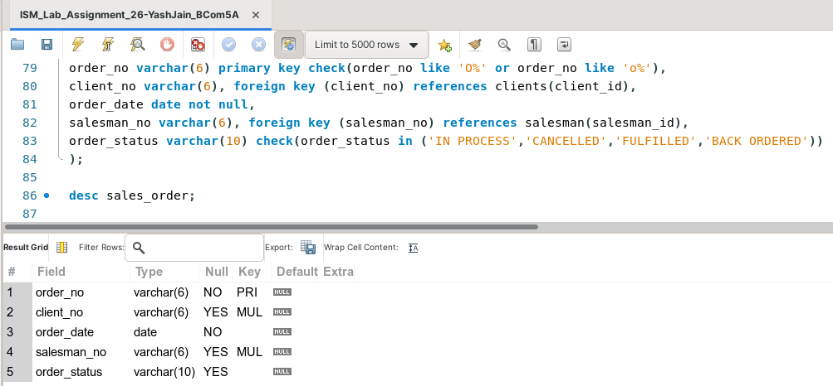



**Task 8: Insert the following values in the SALES_ORDER table:**

|  |  |  |  |  |
| --- | --- | --- | --- | --- |
| **ORDER_NO** | **CLIENT_NO** | **Order Date** | **Salesman No** | **Order_status** |
| O19001 | C00001 | 12-JUNE-2004 | S00001 | IN_PROCESS |
| O19002 | C00002 | 25-JUNE-2004 | S00002 | CANCELLED |
| O46865 | C00003 | 18-FEB-2004 | S00003 | FULFILLED |
| O19003 | C00001 | 03-APR-2004 | S00001 | FULFILLED |

This task can be completed using the **INSERT INTO** Command**.**

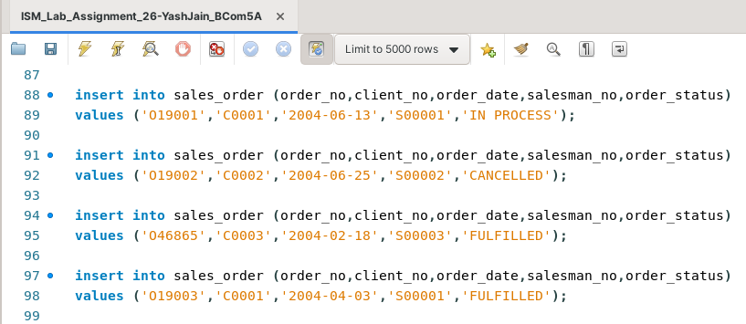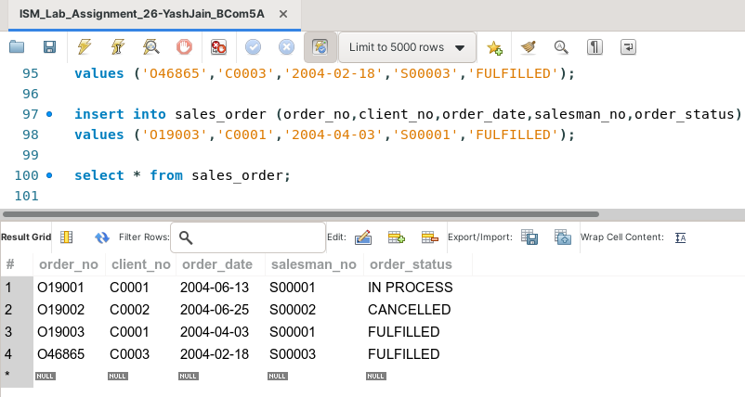

**Task 9: Create the following table with the given attributes:**

Table Name: **SALES_ORDER_DETAILS**

|  |  |  |  |  |
| --- | --- | --- | --- | --- |
| **Column_ Name** | **Data Type** | **Size** | **Default** | **Attributes** |
| ORDER_ NO | VARCHAR | 6 |  | REFER  SALES_ORDER |
| PRODUCT_NO | VARCHAR | 6 |  | REFER  PRODUCT_MASTER |
| QTY_ORDERED | INTEGER |  |  |  |

This task can be completed using the **CREATE TABLE** command, along with the **Primary Key, Foreign Key** constraints.

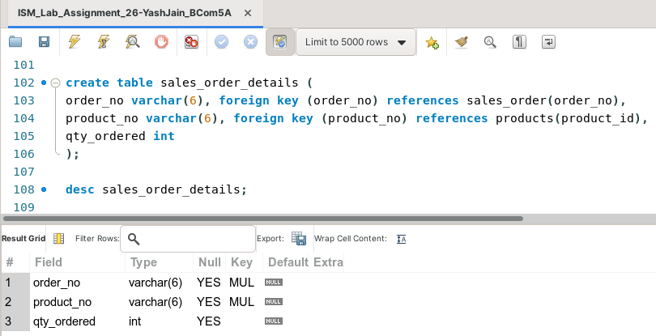

**Task 10: Insert the following values in the SALES_ORDER_DETAILS table:**

|  |  |  |
| --- | --- | --- |
| **ORDER_NO** | **PRODUCT_NO** | **QTY_ORDERED** |
| O19001 | P00001 | 4 |
| O19002 | P00001 | 10 |
| O19003 | P0345 | 4 |
| O46865 | P07865 | 1 |

This task can be completed using the **INSERT INTO** Command**.**

